Rutland Area Food Co-op Board Meeting
May 24, 2018

Present:
Board: Chris Littler, Hannah Abrams, Steve Peters, Mckenna Hayes, Matt Poli, Dave Tibbs, Molly Nitka, Tyler Richardson, Laura Daubenspeck, Kate Thomas, Irene Gold,

Missing:
Staff: Zach Stevens, Jamee Sherwin
Guests: Chris Ettori, Gerd Hirchmans, Rod Monroe
Notes:

Meeting brought to order: 6:32 p.m.

Introductions: Prospective board members Rich, Chris, and Erin.
Minutes:
Hannah motions to approve April minutes. Chris Seconds. Approved

FINANCE COMMITTEE – Chris L.
Last Month
- Sales were down $12,604 (7%)
- Net Income of $5,335.68 (up $1,173 from last year)
- Weather hurt sales again with snowstorms and cold days still in April
- Staff was aware, thanks to Zach, of slow sales and ramped back ordering. Cost of goods was down $17,000 from last year
- $1,300 in professional fees for Jeff Glassberg
- Spent $1,000 for giveaway items for the Annual Meeting. We should recover some of that money once we start selling the leftover items.
- Dues and Subscriptions were down this month because they were paid last month.
- Janitorial expenses were up because there was still snowplowing bills in April
- We made $30.57 in interest. Picnic time!
This Month
- Sales for May are down $4,000 as of the finance meeting.
- Co-op is doing demos and new signage and hot meals are beginning to take off. Hoping this cuts down on those losses.
- Have not heard back from Mark yet regarding extending the decreased rent due to delayed construction. Mark has verbally confirmed that he’s received and reviewed the email regarding this topic.
- Will check with CPA next week for timeline on when they should have our info back to us.
- Plant starts are in and doing well
- Store will be closed on Memorial Day
- May has 5 pay weeks, so that will increase expenses
- Expecting more expenses from annual meeting
- Co-op received a $500 check from Barleans. Co-op (and former board member) Dianne Hayes won their mail-in-contest. The Co-op got a check for one of our members winning!
- Working on scheduling a meeting with the CPA to discuss moving the membership money and when we should expect to see our numbers back this year.

PATRONAGE COMMITTEE – Steve Peters
- Last in-store event is on Wednesday May 30th at 3pm to 4:30pm with Irene.
- We have not received much concern with switching over to patronage.
- We do need to change our bylaws to move to patronage. The Springfield bylaws have been made available for viewing in the Dropbox, and Steve on behalf of the policy committee is looking for someone to review them.
  - Kate volunteered to review them and track down answers to any questions she has after review. The board will vote through email.

NOMINATION COMMITTEE – Hannah
- Three applications have been submitted
- Due to changing numbers of people interested, we have not determined if it will be ballot voting or not.

ANNUAL MEETING – Steve Peters
- We are up to 98 RSVPs! Although we’re looking for 150, so start inviting people!
- Vendors are Spatzle, Tre tap, and one29 foods
- Steve working on creating a ballot for voting for board members
- Thinking of having the patronage vote being on the back side of the board ballots
- Branded Item surprise to be handed out at Annual Meeting Reveal! Looks amazing!
- Looking for definitive confirmation that members need to vote on policy governance adjustments. As the policy governance is not a bylaw, members of the board who spoke believe we have the right to change those errors. Zach suggested that we reach out to Middlebury Co-op for clarification as they also use policy governance.
  - Matt suggested that we use a consent agenda to vote in previously approved policy governance changes.
  - It was suggested that once the new board is assembled, make policy adjustment immediately when an update is required.
  - Steve and Kate will begin working on the updated policies for June’s BOD meeting.

STRATEGIC PLANNING – Zach and Hannah
- See new boards

MEMBERSHIP UPDATE – Laura and Zach
- Zach reached out to Springfield Co-op to see if signatures are required for updated membership records. Springfield emailed back they are also going to review this topic.
- Laura is not going to re-run for the Board, as such, we will need someone to step into the leadership position for this position. At this point, it’s primarily researching policy and writing it up.

PG Reports
Reminder: The Sunday before the Board Meeting, please email PG Reports to the whole Board and Zach as well as place it in the Drop Box.

B1 – Financial Condition and Activities - Zach
This report has been generated using reports from the last two years to show trends. The actual report status is based solely on the current complete data of the three previous quarters ending 3/31/18 and additional data ending 4/30/2018. Unless otherwise stated with an exception, all data in this report is accurate as of 3/31/2018.

I certify that the information contained in this report and its attachments are true.

Signed, Zach Stevens, General Manager

B1- With respect to the actual, ongoing financial conditions and activities of the RAFC, the GM shall not cause or allow the development of fiscal jeopardy or material deviation of actual expenditures from Board priorities established in Ends policies.

Interpretation: The policy states the criteria that we base our financial practice and assessment on which is outlined below. We use the following to measure our financial performance and look at trends to make informed decisions. If we fall out of compliance in any areas, it is the GM’s responsibility to report on what may be a factor and our working plan towards compliance.

Data: The data collected is presented under each sub-policy below.

Conclusion: We are out of compliance in sales growth and proper record keeping. Justin and I are working on a few initiatives to boost summer sales. The board has established an unofficial membership committee who is helping work through and update our membership policies and records. Please see the data, strategic plans, and timelines for each section below as well as attached financial reports.

- Allow sales to decline or be stagnant.

Interpretation: Management strives for growth in sales in order to keep up with market inflation, operational increases and allow the business to expand its offerings. Sales growth should be above 3% to be in compliance.
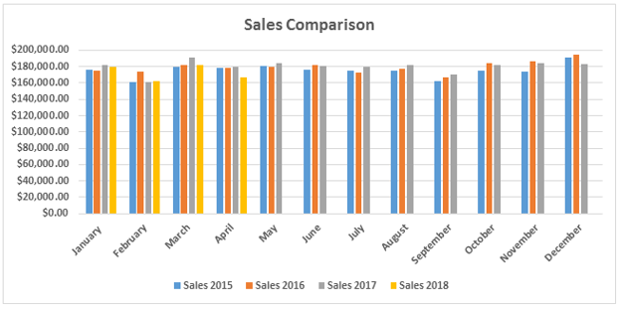
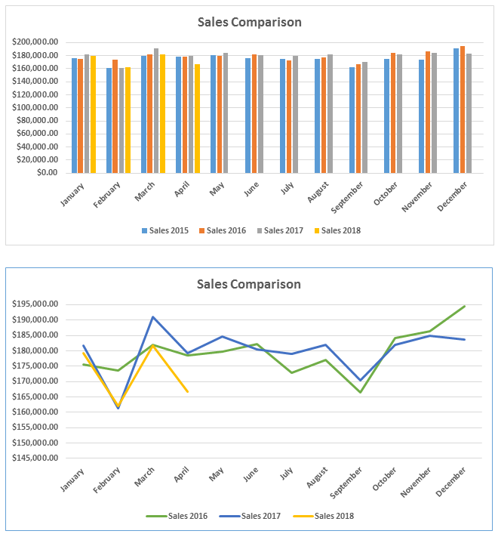
Data: Sales for Qtr. 4 were down $-11,768.13 or -2.1%. Sales for last fiscal year ended down $-6,936.55 or -.3%.

Conclusion: It is this manager’s conclusion that we are out of compliance.
Plan: Our plans for increasing sales include:
- Two new shelving units by the take-out area- expected completion end of June 2018
- A larger bread section- End of June
- Continuing to increase our social media presence and in-store demo’s
- We are surveying customers in the next 2-3 weeks to see what their currents needs are and what we may be able to do to increase sales before the renovation/expansion.
- Department managers are receiving monthly and mid-monthly updates, so they can better promote their departments and sale items.

Our goal continues to be to work toward the 3% by the end of Q2 2018.2019.

2.) Allow operations to generate an inadequate net income.
Interpretation: Management strives for a positive net number and uses operational strategies, planning and organization to meet this goal, Net income should be greater than 0 (Zero) to be in compliance.
Data:

Net income was $5,819.74. for Q4 of 2017.2018. Net Income for last fiscal year, before CPA adjustments, (4.1.17-3.31.18) is $65,266.95 compared to $44,787.66 the previous fiscal year.
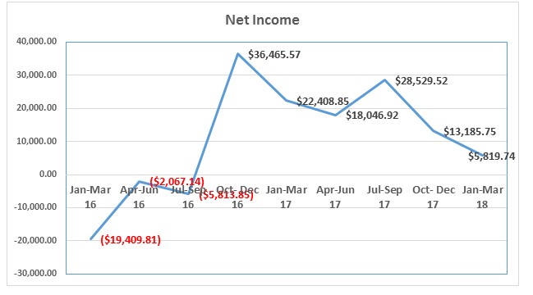
(Net Income) Conclusion: In compliance.

3.) Allow liquidity, or the ability to meet cash needs in a timely and efficient fashion to be insufficient.
Interpretation: The current ratio, Current Assets divided by Current Liabilities, is a common measure of liquidity. The Current Ratio should be above 2 to be in compliance.

Data: At the end of March 2018 our current ratio is 3.81. Conclusion: In compliance.
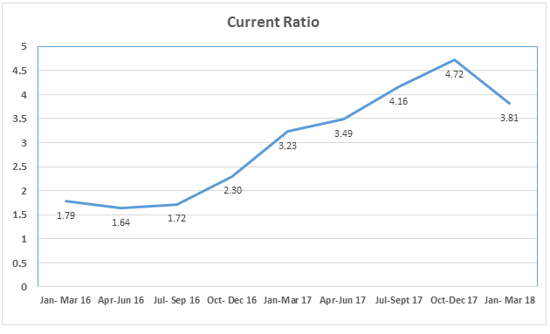

4.) Allow solvency, or the relationship of debt to member/owners’ equity, to be insufficient.
Interpretation: The debt to Equity ratio, Total Liabilities divided by Total equity is commonly used measure of solvency. Our Debt to Equity ratio must be below 2.0 to demonstrate compliance.
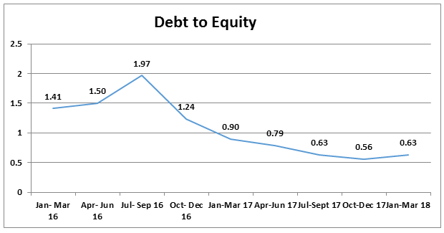
Data: solvency = .63

Conclusion: In Compliance

5.) Incur debt other than trade payables or other reasonable and customary liabilities incurred in the ordinary course of doing business.

Interpretation: Management may not incur new indebtedness except as trade payables, ordinary credit lines, and leases for equipment necessary in ordinary course of business.

Data:
Co-op fund of New England $150,000 Revolving Line of Credit, Annual Interest Rate = 6.00%, Terms=5 years. Granted July 19, 2013. Loan has been readjusted for another 5 years as of January 2018.

No drawdowns since January 2016. Credit line increase to $150,000.00 January 2018.
Current total of loan without interest is $50199.11 as of 3/31/18.

Conclusion: In Compliance

6.) Acquire, encumber, or dispose of real estate Interpretation: This policy limits the GM from purchasing or committing to purchase and real estate; only the Board has the authority to make any kind of real estate (land or buildings) deal.

Data: No commitments or purchases have been made.

Conclusion: In Compliance

7.) Allow tax payments or other government-ordered payments or filings to be overdue or inaccurately filed.

Interpretation: Management will ensure that our payments of filings are timely and current.
Data: All payments and filings are current, timely and up to date.

Conclusion: In Compliance

8.) Allow late payments of contracts, payroll, loans, or other financial obligations.
Interpretation: Management will ensure that all accounts and financial obligations are current and in good standing.

Data: All contracts and accounts are current and in good standing.

Conclusion: In Compliance

9.) Use restricted funds for any purpose other than that required by the restriction
Interpretation: Management will use funds appropriately and only from accounts that are intended for the expenditures. If an exception occurs and Board approval is necessary, Management will present the information so the Board is aware and agrees with the proposed methodology.
Data: All funds are used appropriately from the intended accounts. All payments have documentation attached and are entered in QuickBooks and filed accordingly.

Conclusion: In Compliance

10.) Allow financial record keeping systems to be inadequate or out of conformity with GAAP.
Interpretation: Management will keep accurate records, controls and financial practices in place that in the best interest of RAFC. Annual assessment of these practices will keep them current and appropriate.

Data: Records, controls, and financial practices are in place. A financial review is completed annually by McCormack, Guyette and Associates. We have signed our commitment letter for 2018 and have turned in our finances. The last review for year-end 3/31/17 is available at the Co-op or in Drop-box. We have found that our categorizing of membership income is incorrect, and our member data and records need updating.

Conclusion: Out of Compliance

Plan/Timeline- The board has formed an unofficial membership committee that has finished searching through the Co-op records and has started to work on crafting our new membership policies. Once the new policies have been agreed upon and perimeters outlined we will then enter all our membership data into one system for accuracy and proper tracking. This process will take the entire summer 2018 to complete.

Laura motioned to move out of compliance with appropriate plan. Dave seconded. Approved.

B2 – Business Planning and Financial Budgeting – Zach
The General Manger shall not cause or allow business planning and budgeting, for any fiscal year or the remaining part of any fiscal year to deviate materially from the Board’s Ends priorities, risk financial jeopardy, or fail to be derived from a multi-year plan.
The GM will not cause or allow plans that:
- Risk incurring those situations or conditions described as unacceptable in the Board policy “Financial Conditions and Activities.”
- Omit credible projection of revenues and expenses, owner investment and return, separation of capital and operational items, cash flow, and the disclosure of planning assumptions.
- Plan expenditures in any fiscal year that would result in default under any of the Cooperative’s financing agreements or cause the insolvency of the Cooperative.
- Have not been tested for feasibility.
- Provide less for Board prerogatives during the year than is set forth in the Governance Investment Policy.

Data:
The GM works diligently to maintain the “Financial Conditions and Activities” as provided in Policy B1.
Reports and proposals are prepared as part of the planning process and are provided to all parties for review and approval.
Plans for any Co-op expansion and growth are discussed as a group and are organized and documented appropriately.
Spending measures have been set to assure appropriate Board involvement and decision making. The GM reports issues and financial discrepancies to the Board in the appropriate timeframes.
Professional third-parties are hired to consult and advise in large project management.
The strategic planning committee continues to meet quarterly and annually to set and update goals.
The new budget for fiscal year 2018. 2018 has been reviewed, implemented, and is projected to maintain financial health. (See drop box for full report).

Conclusion: In compliance

Signed, Zach Stevens, General Manager
Chris motioned to move in compliance. Matt seconded. Approved.
C4 – Board Meetings – Molly
Board Meetings are for the task of getting the Board’s job done.

- We will use board meetings time that is the whole boar’s responsibility. We will avoid committee issues, operational matters and personal concerns.
- Meetings will be open to the membership except when executive session is officially called.
  - We may occasionally use executive session to deal with confidential matters as long as the purpose of the session is started. When possible, announcement of the executive session should be on the published agenda.
- We will make decisions in accordance with consensus, as required by the bylaws. (see Section 5.4)
- The meeting agenda will be determined by the board facilitator, and may be modified at the meeting by consensus of the board.
___________________________________________________________________________
- Is this policy clear? (Yes/No/Comments)

Yes

- How have we been IN of compliance?

We generally use board time appropriately, although I believe we could be more efficient with time management. Utilization of Robert’s Rules was mentioned at our last meeting. I propose we look into utilizing Robert’s Rules for efficiency, efficacy, and consistency purposes.
Meetings are open to membership, although we possibly could be better about conveying this to members last year’s C4 policy sheet states that meeting dates and times are posted for members. Is this still the case? I have not seen them. Perhaps mention this to marketing dept. as something that needs to be shared out via social media, newsletter, etc..
Meetings are posted on the bulletin board and listed on the website.
The purpose of each executive session is usually stated, although I don’t know that we have a formula for that

- How have we been OUT of compliance?
We have not been out of compliance in any significant way in my opinion.
- Recommended changes:
My only suggested change is implementation of Robert’s Rules if we feel this model is a good ‘fit’ for us.
GM Report
- Last Month
  - As Chris mentioned April was a horrible month for sales.
  - As such, we are starting the fiscal year down.
- This Month
  - We are still searching for a full-time kitchen manager, haven’t received many applications. Please share with anyone you think may be or knows someone who may be interested.
    - Looking to post on restaurant focused job boards, Front Porch, and other job-boards
  - Assistant Manager Melissa Rixon started last week, and came in today for a few hours, she will start full-time next week. Please introduce yourselves when you are in shopping.
  - Large freezer froze up again two weeks ago small loss in product, had to have it serviced, and had Tech do annual cleaning of condensers.
  - Customer survey went out via email yesterday. We have already received 62 responses (about 30% response rate). Please fill it out when you get a moment. In-store copies are at register and will be available at the meeting.
  - Sales for May as of Monday were up $60.00! As of yesterday, we are down $3,000 or 2%. We are keeping a very close eye.
- Future
  - We will be closed Monday 28th for Memorial Day!
  - Annual Meeting RSVP’s 95 so far!
  - New shelving units will be coming and bread department moving.
  - Justin would like me to ask everyone to please share, post, like our demo’s and posts on both the Instagram and the Facebook (mention it to husbands, wives, kids, and family friends as well).

Board Facilitator Monthly Update – Hannah
- Moving forward with member loan offering. Have received a shell memorandum (provided in appendix). Hannah will continue to fill in and work on the offering. Would appreciate Kate’s feedback over the next few weeks. Hannah will highlight where information updating is required.
  - Looking to start the loan campaign in September.
  - Member loans would start at a minimum of $500 to participate
- Update on Director and Officer Insurance. Hannah has been in touch with insurance agent and submitted a general application. We have received one bid back but looking to receive more bid before making a decision. We anticipate that it will be around $1000 annual premium.
- Board Project night coming up to clean parking lot, windows, field, and sidewalk! Wednesday May 30th from 6pm to 7:30pm. We have the required number of board volunteers; however, everyone is welcome!!
- Painting night is TBD, please keep an eye out for it.

Expansion and Renovation Toolbox
- Irene commentated on how comprehensive the toolbox handout was.
- Kate asked if we have done the Self-Diagnostic Tool, and if not, she suggested that we do so.
  - Zach reminded everyone that, ideally, we would like to be profitable for at least two more years prior to doing an expansion, however as the landlord is change the building we have no choice but to expand now. Regardless, Zach will start to plug information into the Diagnostic.
  - Building off the comment that the renovation of the building is forcing our expansion. The Lease Committee has investigating the logistics of moving the co-op as opposed to expanding it, and it was determined that it was better to work with known risks here, the move and experience new risks.

New Business
- Research Robert’s Rules – Tyler and Kate have sent a cheat sheet to the board on what needs to be done, how to do it, and if it requires a vote.
  - For example, when it’s time to adjourn, you say “It’s time to adjourn”, there’s a rule whether you can interrupt a speaker, if there’s a second needed, a vote is needed, is it debatable, is it amendable, is a majority vote required.
  - Tyler has a companion piece that he’s forward to the board regarding intro to preliminary rules.
  - Chris moves we table this until we’ve read the two cheat sheets for further discussion next meeting. Kate seconds motion and moves to add Robert’s Rules to agenda next month.
Next Month
- Agenda Items for next month
  - Robert’s Rules – Tyler and Kate
  - Can we operate off the cheat sheet or do we need to officially adopt the complete rules? Can we operate off it for a trial period of a few months before officially adopting it? Etc…
- Mckenna will not be present for June’s Meeting
- Consent agenda with policy changes
- Lease Committee: TBD
- Annual Meeting Committee: Wednesday, June 13th at 4:30 pm
- Finance Committee Meeting: Wednesday, June 20th at 6 pm
- Board Meeting: Thursday June 28th at 6:30 pm
- A – Ends – Zach
- C5 – Code of Conduct - Irene

Executive Session: N/A
Meeting closed: Hannah motions to adjourn meeting. Kate Seconds. Majority approved. 8:08 pm

Appendix

RUTLAND AREA FOOD CO-OP
Rutland, Vermont
**[__________] 2018

CONFIDENTIAL OFFERING MEMORANDUM
MEMBER LOAN PROGRAM:
INFORMATION FOR PROSPECTIVE LENDERS

Offer Expires **[__________], 201__
(unless extended or earlier terminated by our Board of Directors)

Offered only to Vermont residents who are
members of
Rutland Area Food Co-op

Reviewed by the law firm of Dorsey & Whitney LLP

Summary of the Offering
Rutland Area Food Co-op is soliciting loans from its members to raise funds needed to expand its facilities. The Co-op intends to raise up to an aggregate amount of $**[__________] through the member loan offering, with a minimum offering amount of $**[__________]. The loans will be unsecured and will bear simple interest at an annual rate between **[zero and three percent]. Loans will mature in **[4, 5, 6, 7 or 8] years at the choice of the member. The minimum individual investment is $**[__________]. There is no maximum investment, except as described below in “About the Member Loan Offering.” Within these parameters, the interest rate and term of the loan is subject to negotiation with individual lenders. This member loan offering is limited to existing members who are residents of Vermont and are at least 18 years of age. The loans are inherently risky. They should be considered only by persons who have adequate financial means and can afford to assume the risks involved, forego liquidity in the funds lent, and possibly sustain a loss of such funds.

About the Co-op
Rutland Area Food Co-op (the “Co-op”) is **[describe co-op history, membership, principles, and values].
The Co-op is incorporated under the laws of the State of Vermont as a cooperative association for the mutual benefit of its members as patrons of its goods and services. Our corporate status is in good standing.

About the Expansion Project

**[Describe the expansion project.]

Financing the Expansion
A key ingredient in our strategy to facilitate the expansion is to raise member loans that will leverage outside debt. We are offering our members the opportunity to support the Co-op’s efforts by providing a member loan.
The following is a summary of the costs and expenses of the expansion project and how we currently intend to apply the proceeds of this member loan offering:
**[Insert sources and used projects for both the minimum offering amount and the maximum offering amount.]
Sources:
**[To be inserted.]

Uses:

**[To be inserted.]

About the Member Loan Offering
This Offering Memorandum details the terms, conditions and risks associated with making an investment in the Co-op. The Co-op intends to raise up to an aggregate amount of $**[__________] **[May not exceed $1M.] through the member loan offering, with a minimum offering amount of $**[__________]. This member loan offering will remain open only until the earlier to occur of (1) the maximum offering amount of $**[__________] is fully subscribed or (2) **[__________], 201__, unless extended by our Board to a date no later than 12 months from the commencement of the offering. The Co-op reserves the right to terminate this offering at any time and to reject subscriptions for any reason in our sole discretion. Under Vermont law, the offering period may not exceed 12 months, but we may extend the offering in additional 12 month increments by renewing our filing with the State of Vermont unless the Co-op does not meet the minimum offering raise in the first 12 month period, in which case all proceeds from member loans will be returned to lenders.
This solicitation is directed only to persons who are both existing members in good standing of the Co-op and bona fide residents of the State of Vermont, and loans will be accepted only from such persons. The minimum loan amount is $**[__________]. The maximum loan amount in general is $10,000. The Co-op welcomes loan amounts greater than $10,000 from lenders who meet certain heightened investment standards required by law. If a lender is interested in investing in an amount greater than $10,000, such lender should contact the Co-op as listed in “How to Invest” below to determine if such lender qualifies as a Vermont Certified Investor or an Accredited Investor.
Loans will bear simple interest (not compounded) between **[zero and three percent]. Within this range, the rate of interest applicable to each loan will be selected by the lender. **[Accrued interest will be paid annually within thirty days after the end of each calendar year.] **[Could also accrue during the term of the loan and be paid when the principal is paid out.] Unless the loan amount and interest rate are such as to result in annual interest payments of $10 or less, the Co-op is required to obtain a signed Form W-9 from each lender that provides the lender’s taxpayer identification number and certifies that back-up withholding does not apply.
Loans will mature in **[4, 5, 6, 7 or 8] years. The length of the loan term will be selected by each lender so as to both meet the needs of the individual lender and to ease the repayment burden on the Co-op by spreading the maturity dates of loans over a number of years. Loans will not be secured by a lien on Co-op assets or otherwise. They will be subordinated to loans from institutional lenders. As of **[__________], 2018, the Co-op’s senior term debt consisted of approximately $**[___________] by **[lender].
Promissory notes may not be transferred or assigned except with the express consent of the Co-op. The Co-op will generally consent to a gratuitous transfer, as long as the transferee is a member of the Co-op. The Co-op will consent to a sale or exchange of a note only if it is transferred to a person who is eligible as a lender under this program, and there is no element of profit realized on the transfer. The Co-op may not provide services that would encourage or expedite the transfer of notes.
Proceeds of member loans will be put into a separate bank account pending receipt by the Co-op of the minimum offering amount of $**[__________] and a further determination by our board of directors that funding is sufficient to permit the expansion project to proceed. In the event our board of directors decides we are unable to go forward with the project for any reason, proceeds from member loans will be returned to lenders with a pro rata share of all interest accumulated on the funds during the period that they were held by the Co-op. Vermont law also requires the Co-op to return proceeds from member loans to lenders if the Co-op is unable to raise the minimum offering amount of $**[___________] during the initial 12 month offering period.
The Co-op may, in its sole discretion, prepay any note before its stated due date together with interest accrued to the prepayment date. No penalty or additional interest will be due in the event of such a discretionary prepayment by the Co-op. More detailed information concerning terms of loans is contained in the specimen promissory note attached hereto as Exhibit A.
Lenders will be put on a mailing list to receive annual year-end financial statements of the Co-op as they become available. Year-end financial statements will be audited or reviewed by an independent Certified Public Accountant. Financial statements for the three previous fiscal years are attached as Schedule 1.

Risk Factors
A loan to the Co-op is subject to significant risks that should be carefully considered by any potential lender. Before extending an investment, lenders should carefully consider the risk factors described below and other information contained in this Offering Memorandum. The risks described below are those that the Co-op currently believes may materially and adversely affect us. Additional risks not presently known to the Co-op, or that Co-op currently considers immaterial, may also materially adversely affect the Co-op. **[Consider any other risks particular to Rutland or any changes to the below.]
Business Operations and Competition
The retail food industry is highly competitive. We may be at a competitive disadvantage with respect to investor controlled, hierarchically structured, and profit driven competitors. We are subject to a number of risks inherent in the nature of our business operations and the character of our organizational structure. Such risks include: highly competitive conditions within the retail foods industry, and the potential for competitors having far greater financial resources than the Co-op to enter the Co-op’s market area; the unpredictable character of the natural foods market, which is the fastest growing sector of the retail foods industry; and being consumer controlled, democratically governed, and having a mutual benefit purpose. Competition with other grocers could negatively affect our sales and business position and thus reduce the value of your investment in us. In addition, food consumption and buying trends could change in a manner that hurts our business.
Expansion Risks
The planned expansion may not be successful or may create financial difficulties for the Co-op if the actual costs exceed the estimate, the Co-op’s ability to complete the expansion is significantly delayed, or the expansion does not operate as expected.
Key Personnel
The Co-op relies on a limited number of key personnel, none of whom has any legal or contractual obligations regarding his or her length of service with the Co-op. **[Confirm.] There is no guarantee that the Co-op will be able to recruit and retain qualified personnel with the skills and experience that might be needed by the Co-op.
Speculative and Subordinated Investment
In addition to business risks, there are risk factors inherent in the member loan program. These include: the lack of any liens or security interests for member lenders in Co-op property; the absence of any obligations of the Co-op to periodically make payments into a sinking fund to be used to redeem member loans; and non-liquidity of the loans in that lenders cannot readily convert the loan obligation into cash by selling or exchanging their promissory notes. In addition, member lenders may have difficulty in enforcing their member loans due to the cost of legal proceedings.
In addition, the member loans are subordinated to the loans of institutional lenders. In the event of a liquidation, payment on the member loans would occur only after our other liabilities have been satisfied. As a result, in a liquidation promissory note holders would very likely lose some or all of their investment in the promissory notes.
Investment in the member loan program is a speculative investment. Lenders may not realize any return on their investment. In fact, lenders could lose their entire investment. For this reason, lenders should carefully read this Offering Memorandum and consult with their counsel, accountant or business advisor prior to making a decision to extend their investment in the member loan program.
Tax Issues
You should consult your tax advisor with respect to the federal and state tax consequences of any investment in the Co-op and impact on your tax reporting obligations and liability.
Financing
Assuming that we obtain all of the sources of funds described in “Sources and Uses”, we believe that that the Co-op will have sufficient funding to complete the expansion and meet working capital requirements in the near term. If the proceeds of this offering are not adequate to fund the Co-op’s working capital needs, then the Co-op will be required to seek additional financing for its operations. The Co-op cannot assure lenders that such financing will be available to the Co-op on favorable terms or at all. If additional financing is obtained from institutional lenders, the Co-op’s ability to repay member loans could be impaired.
Offering Not Registered with the SEC or Any State Securities Commission
The securities offered hereby have not been registered under the Securities Act of 1933, as amended, or the securities laws of any state. Any representation to the contrary is a criminal offense. Lenders should not expect to be able to liquidate their investment quickly, even in case of an emergency. Because the member loans have not been registered with the SEC or with any state securities commission, lenders do not have the benefit of review of this Offering Memorandum by the SEC or any state securities commission.
Forward-Looking Statements; Sources and Uses
This Offering Memorandum contains forward-looking statements that reflect the Co-op’s current views and intentions and beliefs about the expansion project and the anticipated financial results of the same. If a sentence contains words such as “anticipates,” “assumes,” “believes,” “ expects,” “intends,” “may,” “plans” or similar words or uses the future tense, it may be a forward-looking statement. Such forward-looking statements and “Sources and Uses” statements are inherently uncertain, and there can be no assurance that the assumptions underlying them will prove to be valid. As such, actual results could differ materially from those contemplated by the forward-looking statements because of certain factors, including, but not limited to, those disclosed under “Risk Factors.” The financial projections contained in “Sources and Uses” may not materialize for any number of reasons, including those outside the control of the Co-op. Lenders are cautioned not to place undue reliance on these forward-looking statements and the “Sources and Uses” statements.
Subscription Agreements
After you submit your Subscription Agreement, you will not be allowed to withdraw your subscription for any reason unless a material change in this offering requires us to make a rescission offer to investors. Upon acceptance by us of your subscription, your cash payment will be invested in promissory notes.
Under the terms of the Subscription Agreements, members who express interest by submitting a Subscription Agreement should not make any payments until requested by the Co-op to do so, as explained in “How to Invest” below. A Subscription Agreement submitted by you creates a legally binding obligation for you to provide payment for the loan amount to the Co-op within ten days upon notice and request. There is a risk that some members may ultimately not make their required payments to the Co-op. If a significant number of members ultimately do not make their payments to the Co-op when required, the Co-op’s ability to complete the expansion project as planned may be affected.
Prospective investors must not construe this Offering Memorandum as constituting investment, legal, tax or other professional advice. Before making any decision to subscribe for a loan, you should read this entire Offering Memorandum, including each of its Schedules, and consult with your own investment, legal, tax and other professional advisors.
Each prospective investor is advised that we will assert that the investor has been advised of and accepted the risks described in this Offering Memorandum if a claim is brought against us or any of our directors, officers, employees, advisors, agents or representatives in connection with this offering or otherwise.

Suitability Standards
In view of these risks, making a loan to the Co-op may be a suitable option for, and should only be considered by, those persons who understand the nature of the risks involved and have adequate financial means to assume those risks, forego liquidity of the funds lent to the Co-op, and possibly sustain a loss of those funds.
These suitability standards represent only minimum standards. Prospective lenders are encouraged to consult their own legal counsel, investment advisor, tax consultant, accountant, or other advisers to determine whether making a loan to the Co-op would be appropriate for their circumstances.

Obtaining Additional Information
Any prospective lender having any questions or wishing to review Co-op records and reports should contact the Co-op’s member loan coordinators as listed in “How to Invest” below. Co-op records and reports that will be made available to prospective lenders include historical financial statements, financial projections and various other business planning materials, biographical information of management and directors, and the Co-op’s articles of incorporation and bylaws. It should be understood that some of these items (such as financial projections) are not strictly factual in nature but are, at most, educated guesses about the future circumstances and prospects of the Co-op. No employee or agent of the Co-op is authorized to make any representations contrary to the representations herein.

How to Invest
If you wish to commit yourself to making a loan to the Co-op under this member loan program, please fill out and sign the Subscription Agreement attached hereto as Exhibit B and deliver it to the business office of the Co-op at 77 Wales Street, Rutland, Vermont. The promissory notes solicited hereby will be issued and sold only through one of the Co-op’s member loan coordinator**[s]:
**[Insert contact(s).]
A lender may not revoke a subscription once submitted to the Co-op. The signed Subscription Agreement creates a legally binding contract that obligates a lender to pay the loan amount (as indicated on the lender’s Subscription Agreement) within ten days upon written notice of acceptance from the Co-op. Lenders are encouraged to send any payment with the Subscription Agreement. The Co-op reserves the right to reject subscriptions for any reason in our sole discretion including, but not limited to, if we believe that the lender does not meet the suitability standards stated above.
This member loan offering will remain open only until the earlier to occur of (1) the maximum offering amount of $**[__________] is fully subscribed or (2) **[__________], 201[_], unless extended by our Board to a date no later than 12 months from the commencement of the offering.
Members who support the Co-op through member loans are playing a vital role in helping to assure a viable and continuing cooperative source of natural foods and related consumer goods and services in our region. Thank you for considering this manner of providing needed financial support for the Co-op.
* * * * *
The undersigned authorized officer hereby certifies that Rutland Area Food Co-op has made reasonable efforts to verify the material accuracy and completeness of the information contained in this Offering Memorandum as of the date set forth below.

By:
Name:
Title:
Date:

