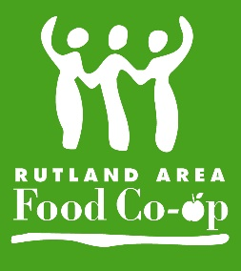
Rutland Area Food Co-op
Overview for Board Candidates

The Rutland Area Food Co-op is governed by a board of directors who are elected by the member-owners. The board is accountable to the owners for the activities and accomplishments of the store. Specifically, it is responsible for:
- Interacting with the owners to understand their values and vision for the store
- Developing, applying, and revising a body of policies that guide the store in achieving outcomes that are consistent with the owners' values and vision
- Ensuring that management achieves the goals set by the board and that the board operates according to its established processes

The Co-op is seeking board candidates who are:
- Members of RAFC who are dedicated to the cooperative, its member owners, and its mission.
- Willing to learn about and contribute to governance of the Co-op.
- Able and eager to deal with values and long-term vision.
- Able and willing to participate assertively in discussions and abide by board decisions and the intent of established policies.
- Willing to operate in a group decision-making environment, to share responsibility in a group process, and to delegate areas of decision making to others.
- Knowledgeable about cooperatives, natural foods, local economies, and/or other areas important to the Rutland Area Food Co-op.

Board members are expected to prepare for and actively participate in monthly board meetings, committee and policy work between meetings, the co-op's annual meeting, an annual retreat, membership events, and occasional board trainings. While this may seem daunting, the board is a team, sharing responsibilities in a way to make board work a manageable part of members' lives.

The monthly time commitment averages about 3-5 hours. The standard term is two years and you may serve up to three consecutive terms.

In return, board members:
- Receive training about cooperatives, boards and other areas as needed.
- Receive a 10% in-store discount.
- Have the opportunity to ensure the success of their community-owned cooperative.

If you would like to learn more, please contact the general manager, Zach Stevens, at management@rutlandcoop.com for a complete application packet, which includes information about by-laws, policy governance and other board activities.

Thank you for your interest and we hope to hear from you soon!

Sincerely,
The Rutland Area Food Co-op Board of Directors
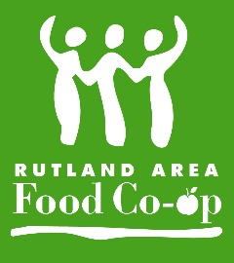
Rutland Area Food Co-op
Board of Directors: Qualities, Commitments and Benefits

This is a summary intended to provide a general idea of the commitments expected of Directors, and the benefits they may expect in return.

Qualities
The Co-op is seeking board candidates who:
- Are dedicated to the cooperative, its member owners, and its mission
- Understand and are willing to contribute to the task of governance
- Have a propensity to think in terms of systems and context
- Are honest and have independent judgment, courage, and good faith
- Are able and eager to deal with values and long-term vision
- Are able and willing to participate assertively in discussions and abide by board decisions and the intent of established policies
- Are willing to operate in a group decision making environment, to share power in group process, and to delegate areas of decision making to others
- Are knowledgeable about and interested in cooperatives and food retailing.

Commitments
- Preparing for and attending monthly board meetings, which typically includes:
- Reviewing any materials for agenda topics and preparing for discussion
- Providing feedback about previous month's minutes
- Providing feedback about upcoming month's agenda
- Participating on committees, which typically includes
- Serving as chairperson or member of a selected committee(s)
- Preparing for committee meetings (scheduling, setting agenda, etc.)
- Recording committee meeting notes / minutes
- Providing reports or other feedback to the Board of Directors.
Other work / events may include:
- Annual members' meeting
- Board training sessions
- Serving on ad hoc committees
- Other work as appropriate

Benefits
- Direct involvement in the steering and direction of the Co-op
- Participation in the member-owner control of the Co-op
- Receive training on Co-op boards and governance
- Receive a 10% discount on store purchases
Rutland Area Food Co-op
Board of Directors
Candidate Application

Name

Address

City/State/Zip

Home Phone
Cell Phone

Email Co-op Member since

Current occupation

Education: include institution, specialization and degrees earned

Special Interests

Board Experience
Organization Years Served Positions Held

Other co-op or board-related experience:

Business and/or Organizational Experience --Please list and briefly describe business and/or volunteer positions you have held:

Skills

Please rate your skills and/or experience in the following areas, with 5 being most skilled or experienced:
 | 1 | 2 | 3 | 4 | 5
Financial & investment analysis
Grocery and/or natural foods
Community groups
Personnel/employee relations
Member/public relations
Consumer issues
Legal Matters
Board or committee administration
Strategic planning
Leadership
Retail operations
Other:
What interests you about serving on the Co-op board of directors?

Please provide a brief biography for the board election ballot.

Is there any additional information that you would like to share with us?

Please email:
□ Your completed application
□ Your resume
□ A photo to be used for the election ballot
to the general manager at the Co-op: management@rutlandcoop.com
Thank you for your interest in serving on the Board of Directors!

