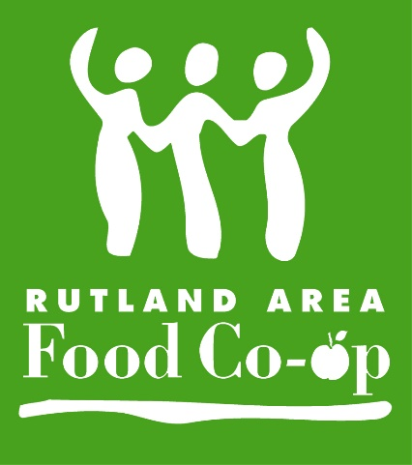**RUTLAND AREA FOOD CO-OP**

***Donation Request Form***

The Rutland Area Food Co-op is happy to contribute to events in our community as they align with our mission. However, we can make no guarantee that we can fulfill your request.

For consideration, please complete this request form and return in store or email to [marketing@rutlandcoop.com](mailto:marketing@rutlandcoop.com) no later than three weeks prior to your event.

**Today’s date:__________________________**

**Organization:___________________________________________________________**

**Organization’s website: ___________________________________________________________**

**Contact Person: ___________________________________________________________**

**Phone number: ___________________________________________________________**

**Email address: ___________________________________________________________**

**Is your organization a 510(c)3 nonprofit? Yes No**

***If your donation is for an event:***

**Please attach any relevant flyers or info.**

**Describe how your event relate to our mission? (See attached.)**

**____________________________________________________________________________________________________________________________________________________________________________________________________________________________________________**

**What kind of donation are your seeking?**

Product donation

Product discount



Gift certificate

Coupon/special offer

Monetary donation

Other:

**How would our donation be used?**

**How will the Rutland Co-op’s support be acknowledged?**